**Assignment 25.2**

**Problem Statement:**

Problem Statement: Write a Hive Program to find the total number of medals each country won.

Problem Statement: Write a Hive program to find the number of gold medals each country won.

**Input:**

<https://d3rzweswlj42yv.cloudfront.net/course/bigdatadeveloper/project/olympic_data.csv>

**Output:**

Creating table Olympics in custom database and loading Olympics data into the table:

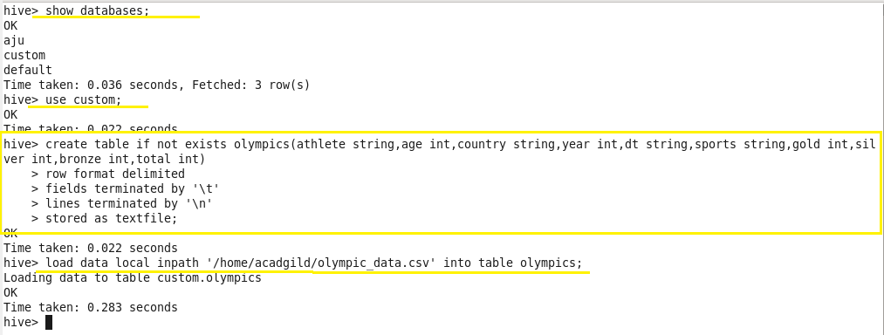

**Problem 1:**

Write a Hive Program to find the total number of medals each country won.

**Output 1:**

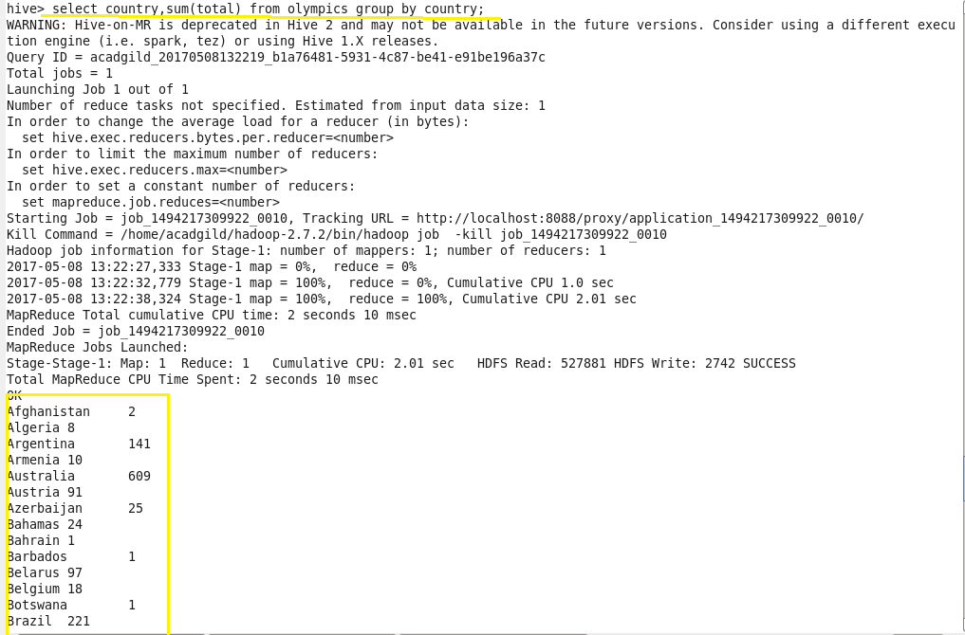

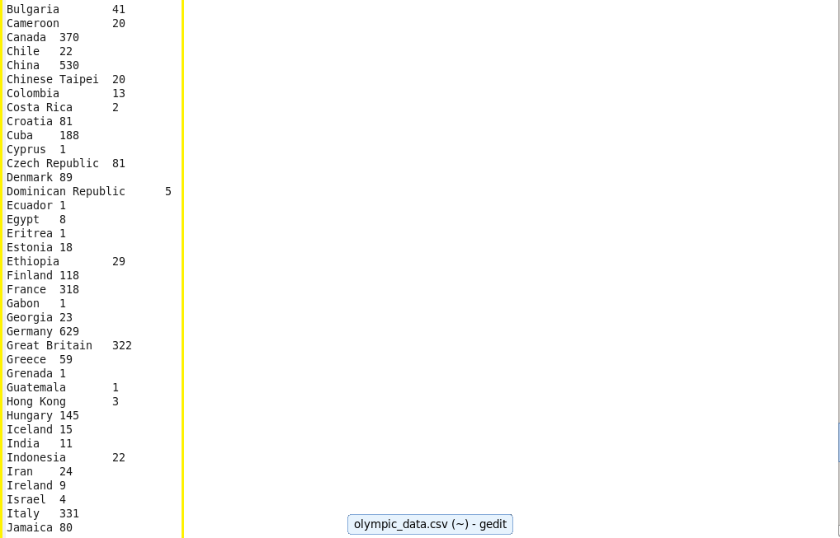

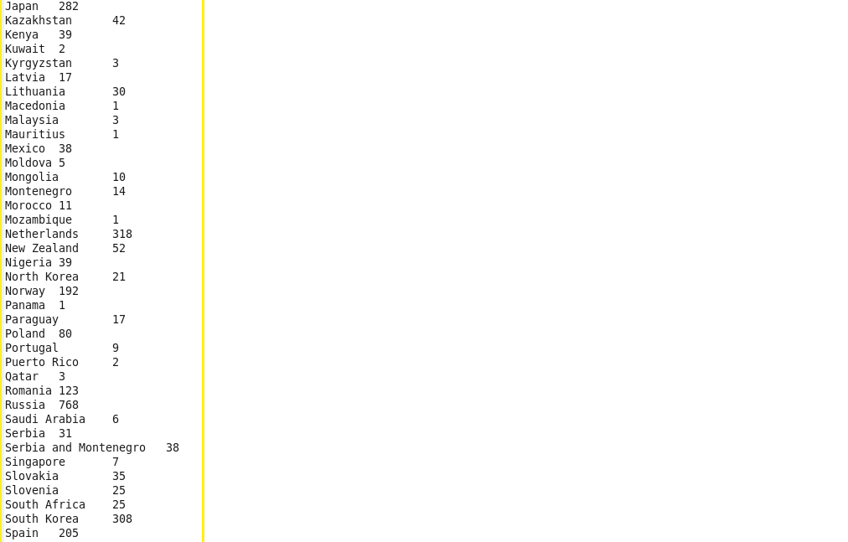

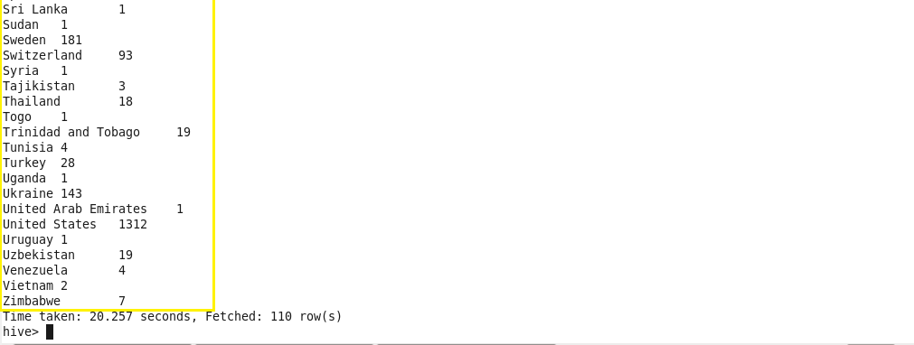

**Problem 2:**

Write a Hive program to find the number of gold medals each country won.

**Output 2:**



